 | American International University-Bangladesh (AIUB)  Department of Computer Science
 | Course Name: COMPUTER GRAPHICS |  | Course Code: CSE 4118
 | Faculty Name: DIPTA JUSTIN GOMES |  | Semester: FALL 2025-2026
 | Section: J  Student Name: NILOY PAUL |  | MID Term LAB Task-1  Student ID: 23-51773-2

Basic Primitive
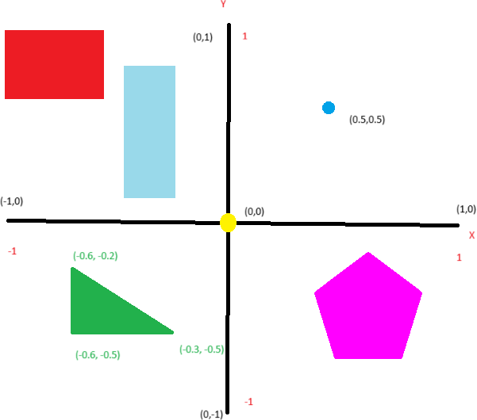
1. Draw the following primitives using OpenGL.

OpenGL Code

#include <windows.h> // for MS Windows
#include <GL/glut.h> // GLUT, include glu.h and gl.h

/* Handler for window-repaint event. Call back when the window first appears and
whenever the window needs to be re-painted. */
void display() {
glClearColor(1.0f, 1.0f, 1.0f, 1.0f); // Set background color to black and opaque
glClear(GL_COLOR_BUFFER_BIT); // Clear the color buffer (background)

//POINT Drawing

glPointSize(10);

glBegin(GL_POINTS);

//drawing the blue point in co-or (0.5,0.5)
glColor3f(0,0,1);
glVertex2f(0.5 ,0.5);

//drawing the yellow point in co-or (0,0)
glColor3f(1,1,0);
glVertex2f(0 ,0);

glEnd();

//LINE Drawing

glBegin(GL_LINES);

glColor3f(0,0,0);

//X-Axis
//Drawing a line with vertex (-1,0) and (1,0)
glVertex2f(-1,0);
glVertex2f(1,0);

//Y-Axis
//drawing a line with vertex (0,-1) and (0,1)
glVertex2f(0,-1);
glVertex2f(0,1);

glEnd();

//TRIANGLE Drawing

glBegin(GL_TRIANGLES);

glColor3f(0,1,0);
glVertex2f(-0.6, -0.2);
glVertex2f(-0.6, -0.5);
glVertex2f(-0.3, -0.5);

glEnd();

//RECTANGLE Drawing

glBegin(GL_QUADS);

glColor3f(1,0,0);
glVertex2f(-1.0, 0.9);
glVertex2f(-1.0, 0.6);
glVertex2f(-0.5, 0.6);
glVertex2f(-0.5, 0.9);

glEnd();

//RECTANGLE Drawing

glBegin(GL_QUADS);

glColor3ub(153,217,234);
glVertex2f(-0.4, 0.7);
glVertex2f(-0.4, 0.1);
glVertex2f(-0.1, 0.1);
glVertex2f(-0.1, 0.7);

glEnd();

//PENTAGON Drawing

glBegin(GL_POLYGON);

glColor3f(1,0,1);
glVertex2f(0.65, -0.1);
glVertex2f(0.35, -0.3);
glVertex2f(0.48, -0.65);
glVertex2f(0.8, -0.65);
glVertex2f(0.93, -0.3);

glEnd();

glFlush(); // Render now
}

/* Main function: GLUT runs as a console application starting at main() */
int main(int argc, char** argv) {
glutInit(&argc, argv); // Initialize GLUT
glutCreateWindow("Welcome TO CG Section-F"); // Create a window with the given title
glutInitWindowSize(320, 320); // Set the window's initial width & height
glutDisplayFunc(display); // Register display callback handler for window re-paint
glutMainLoop(); // Enter the event-processing loop
return 0;
}

Output

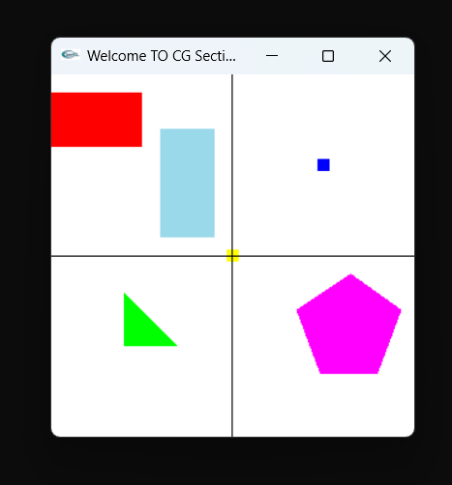

THE END

